FMS Spirit Week April 23rd-27th

- Monday= Circle of Life Day
- Tuesday= Tacky Tuesday
- Wednesday= Workout Wednesday
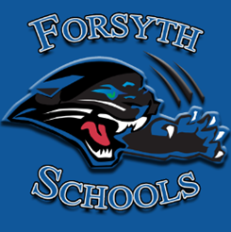
- Thursday= Twinning Thursday
- Friday= Forsyth Spirit Day
Each day a student participates, contributes 1 point to their class’s week-long score!

